**Exercise 2 Report: *Applying Color Maps to Visual for Gender Representation in the Olympics***

***Motivation***

To present information with an unknown population reach, it is important to consider during the design phase of visualizations the different physical limitations of human perception. Protanopia is a condition where a person cannot perceive any red light, deuteranopia green light, and tritanopia any blue light. Considering these physical conditions is of great importance since the consequences can result in misinterpretation of the information presented.

***Tasks***

Different color maps are applied to a visualization from the Winter Olympics covering the years 1924 through 2014 to evaluate the following: What type of color scheme is more suitable for the nature of the data? Sequential, Diverging, or Qualitative? What color map works the best when considering the three types of dichromatic color deficiency Protanopia, Deuteranopia, and Tritanopia? Does changing the color map improve the visualization?

***Expressiveness of design***

The original visualization (*see* *Figure 1*) is designed to capture gender differences over time for the number of medals given (primary axis) among the different sports categories and how the gender ratio (secondary axis) has trended over time. The color map of choice is crucial for providing easy discrimination and identification among sports categories; and clear separation from the trend line. Sports categories are represented with stacked bars using the colors pink, cyan, orange, purple, green, red, and dark blue while the trend line is colored with dark green as well as the secondary axis. All of this is superimposed over a light blue background for the graph.

***Effectiveness of the solution***

Although the original visualization communicates very effectively the color channels of information, it revealed noticeable problems in sports categories and secondary axis coloring when dichromatic color deficiency testing is performed. The color simulation for Protanopia revealed similarities between Skating and Curling with a tone of olive, it also showed how Luge and Skiing have the same color as the background with different shades of gray. Next, in the Deuteranopia color deficiency there are two pairs of colors that are almost identical including Luge and Curling with a tone of olive, and Ice Hockey and Biathlon with a tone of sapphire. The background also looks more gray-purplish which reduces the contrast with the foreground. And lastly, Tritanopia simulation showed how Curling can be confused with Skiing for a similar tone of cyan, there is also a slight increase in light blue tone for the background which still contrasts quite well as compared to the other cases. For all three-color deficiency cases tested, the original dark green color for the secondary axis is blended with at least one of the sports category colors.

In addition, when the original image was tested with the different color patterns for contrast it is quite evident that qualitative format gives the best outcome (*see Figure 4*). This pattern regularly performs better for categorical data, like the one presented in the visualization for the different sports categories.

***Interaction***

Interactive components and features provide the visualization support, even when the color map is not as effective. The original graph provides three features including a hover tool for displaying metadata, zoom ability on every part of the graph to discriminate small details, and legend selection for highlighting related objects. These tools are there to aid users explore and reduce uncertainty for the expressed information.

***Conclusions***

A variety of color patterns and maps were applied to a visualization to analyze the color deficiency defects in three dichromatic conditions. The simulations showed that a qualitative pattern is most effective when presenting categorical data in the stacked bar format. Deuteranopia (*Figure 6)* illustrates the most affected visuals where a total of four colors can be confused, while Tritanopia (*Figure 7)* was the least affected where only two colors can be confused, and the background still maintains high contrast with the foreground. Lastly, a new design is proposed (*see Figure 8*) after revising the topics discussed above where not only a new colormap and pattern were chosen but also a few elements were re-structured such as adding line borders to the bars to prevent the blend of light colors and changing the coloring of the trend line to black as well as adding a legend element for the secondary axis; better effectiveness for this new design is shown in *Figures 9, 10, and 11.*

***Original image and colormap patterns***

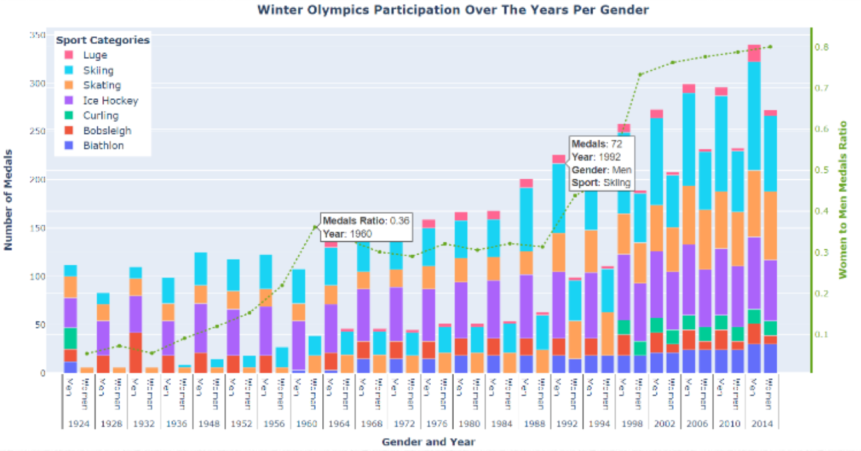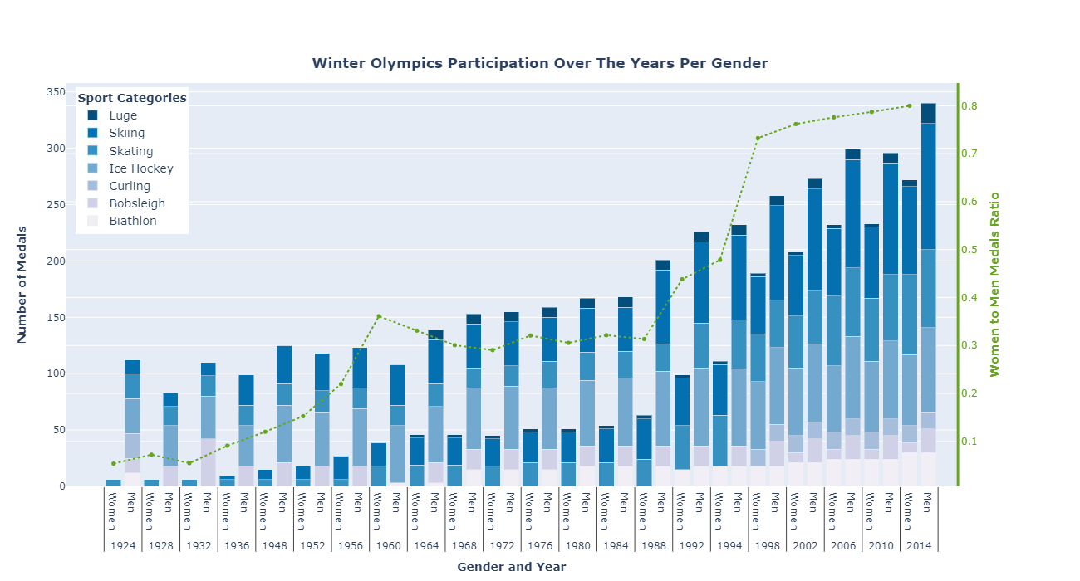

***Figure 1.*** Original Image (Exercise 1)  ***Figure 2.*** Sequential Pattern

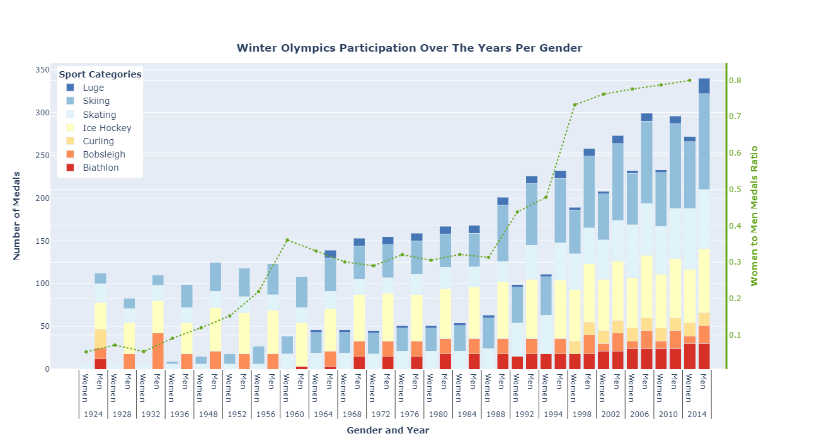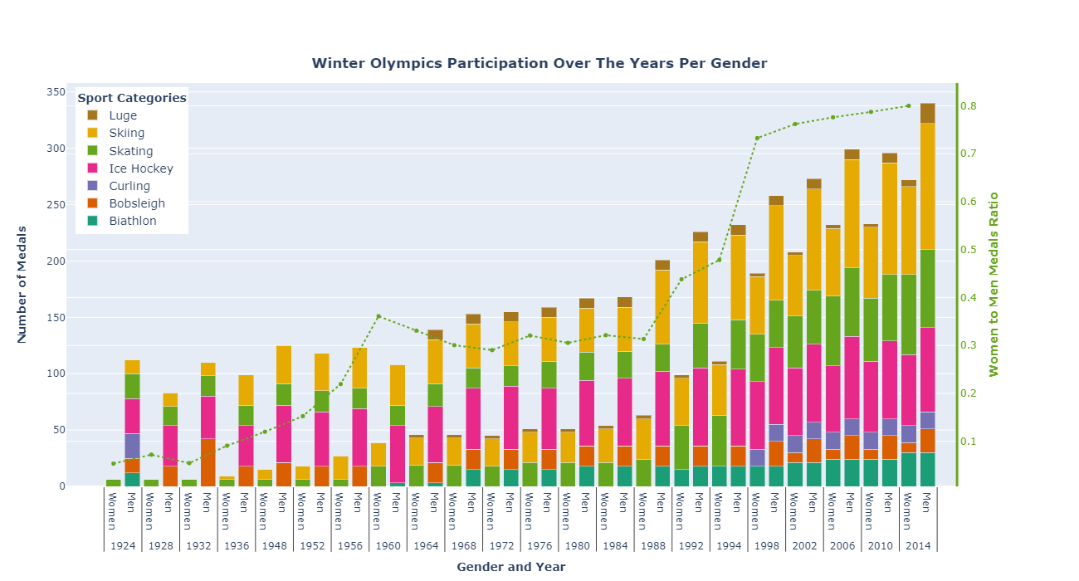

***Figure 3.*** Divergent Pattern  ***Figure 4.*** Qualitative Pattern

***Applied color deficiencies***

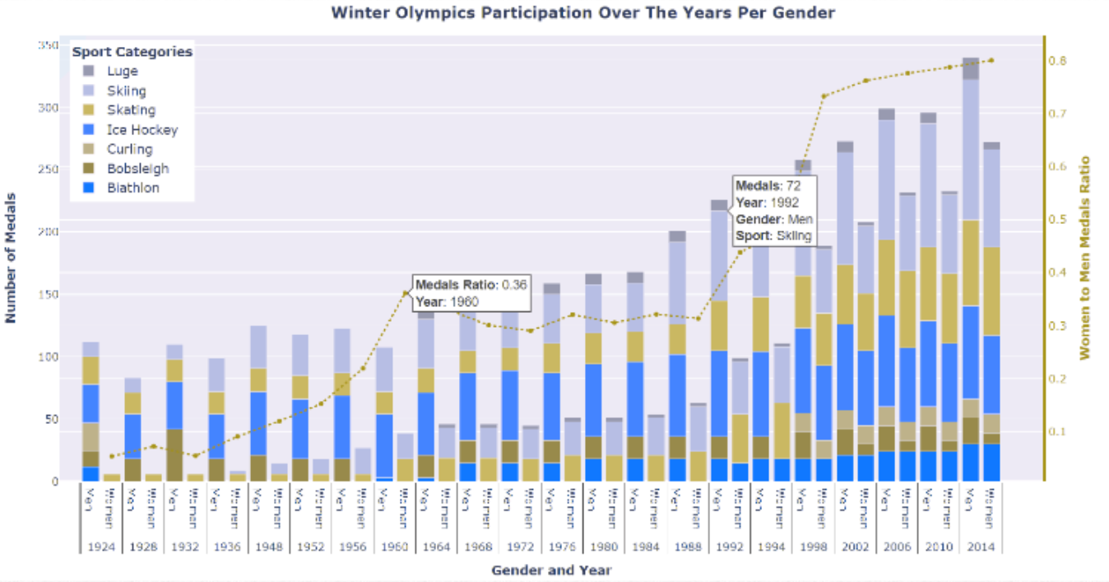 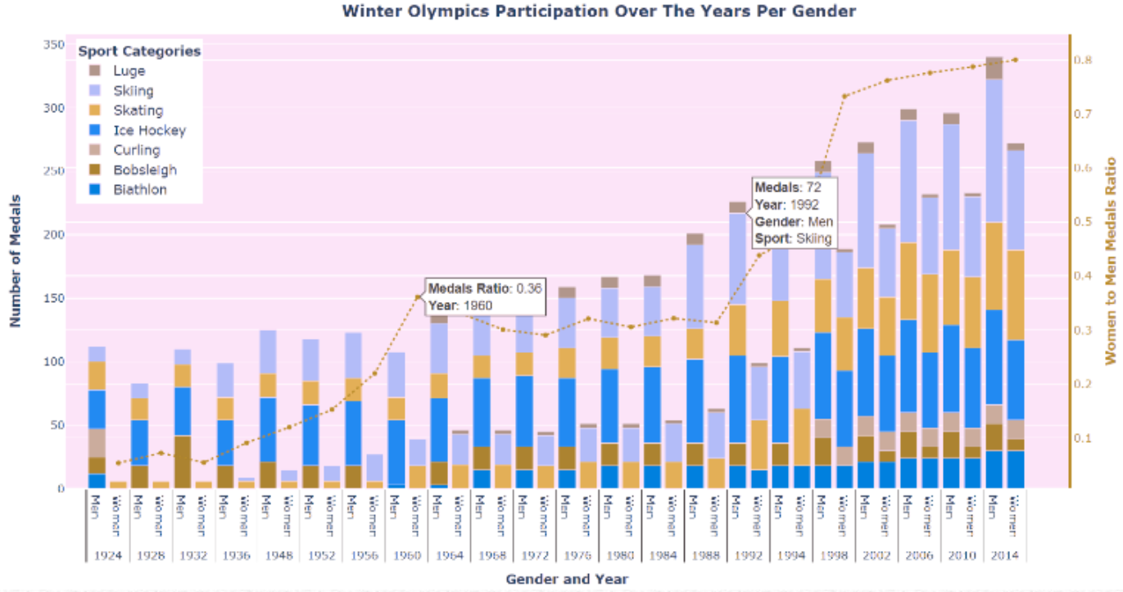

***Figure 5.*** Original image with *Protanopia.* ***Figure 6.*** Original image with *Deuteranopia*

(Red Color Deficiency) (Green Color Deficiency)

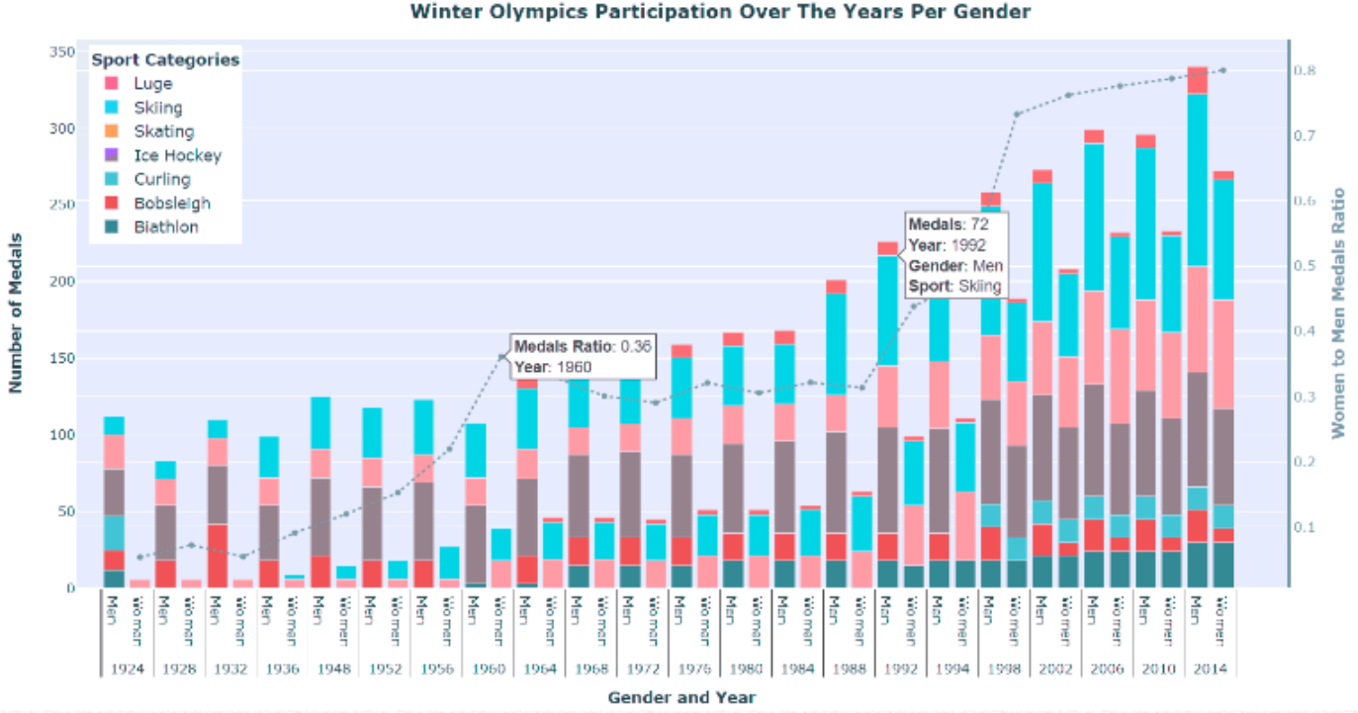

***Figure 7.*** Original image with *Tritanopia*

(Blue Color Deficiency)

***Color safe revised original image with applied color deficiencies***

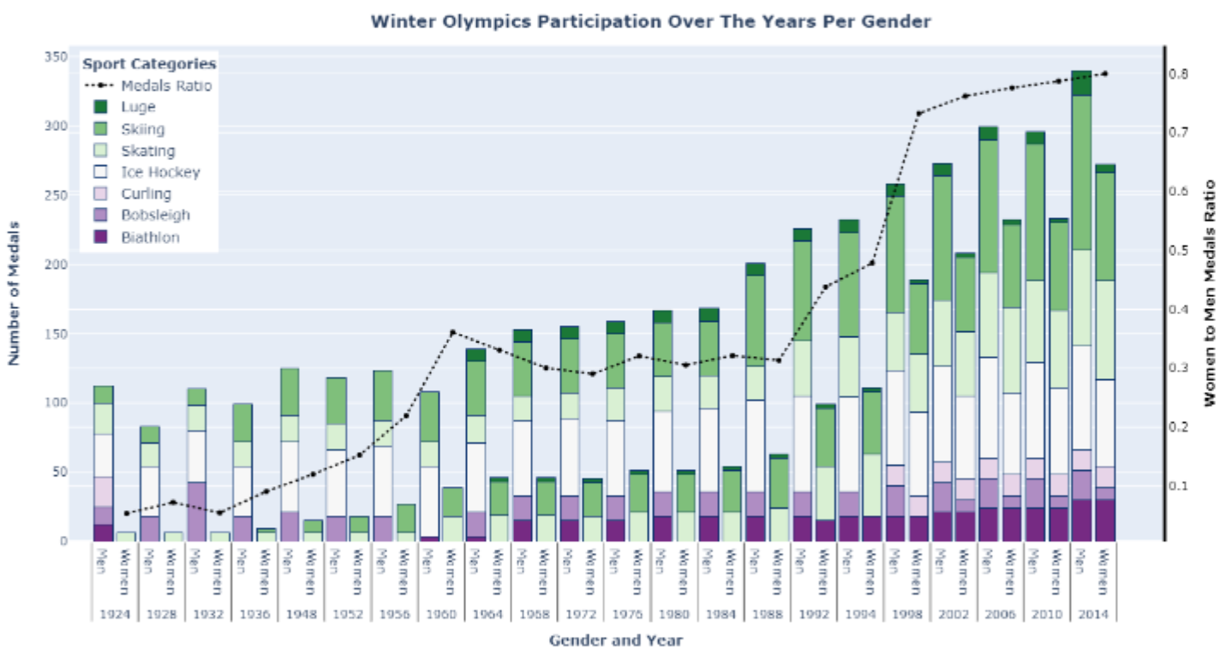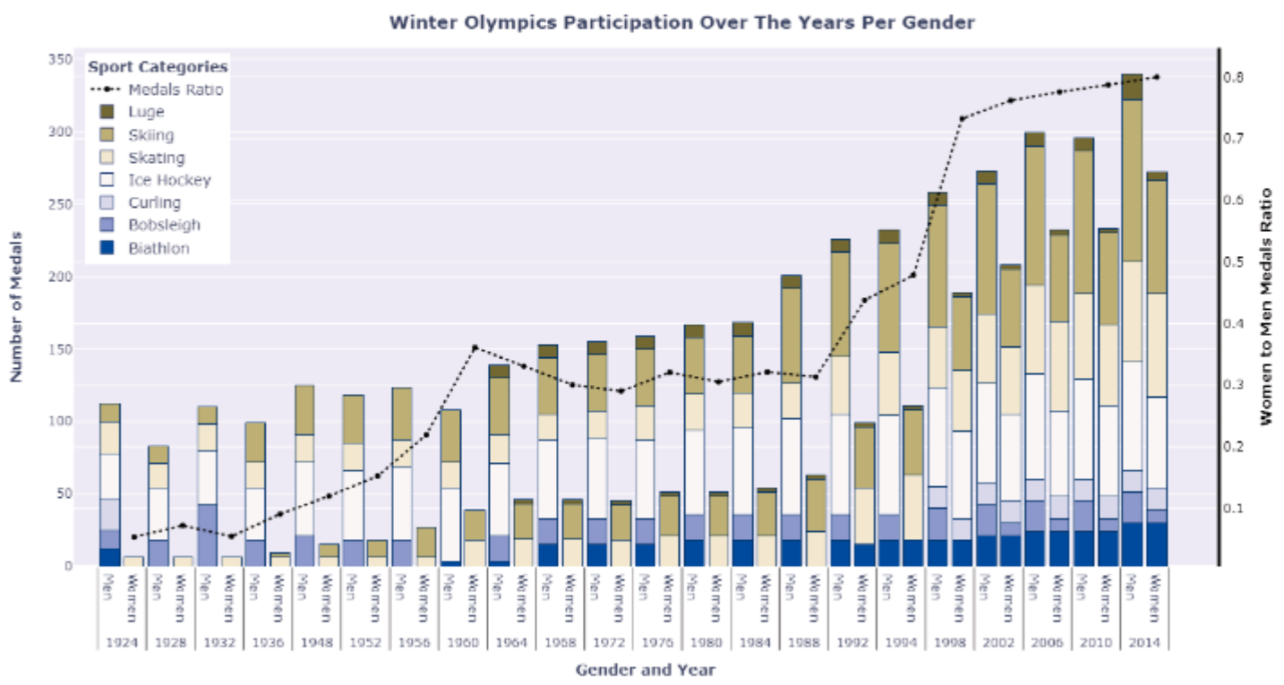

***Figure 8.*** Modified original image ***Figure 9.*** Modified Image with *Protanopia*

(using diverging color map) (Red Color Deficiency)

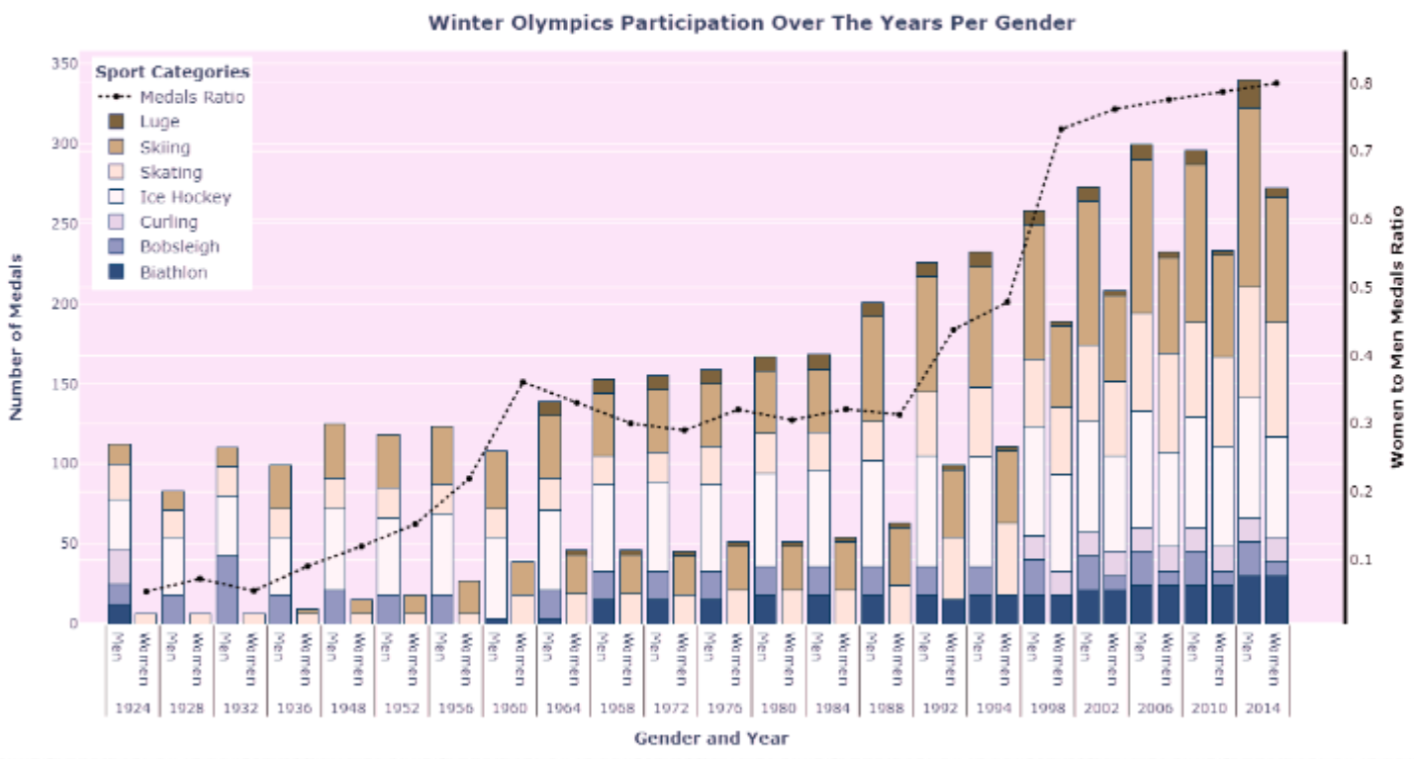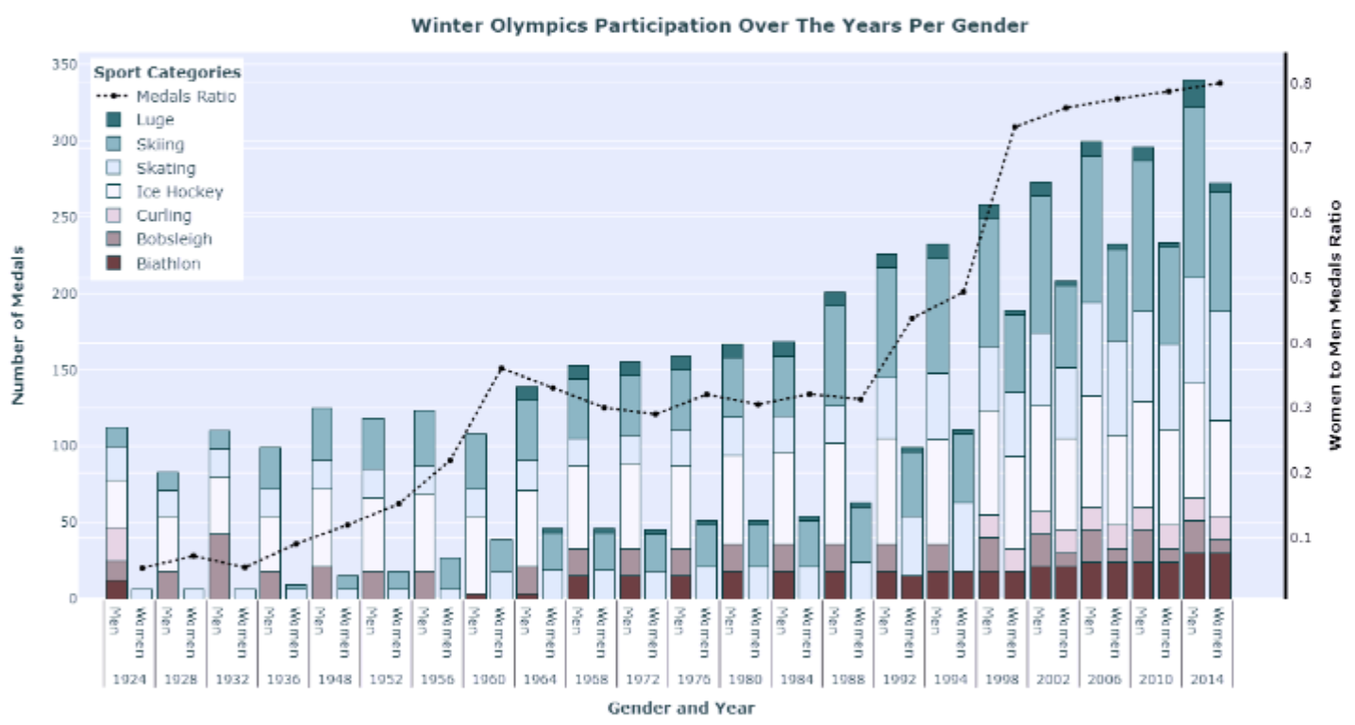

***Figure 10.*** Modified image with *Deuteranopia* ***Figure 11.*** Modified Image with *Tritanopia*

(Green Color Deficiency) (Blue Color Deficiency)